|  |
| --- |
| Chukong Technologies |
| Shaders and Materials |
| PC-3DMAX |

|  |
| --- |
| Cocos3D Team |

Contents

1 Shaders and Materials 0

2 Shader 0

3 Material 0

4 Debug 1

# Shaders and Materials

The *.vsh/*.fsh files are a way of defining how an object is rendered within the Cocos3D engine.

The *.material files are meta-data files that contain artist-editable features, including shader file, shader properties, and texture references. ModelEditor can create and modify material files that can be assigned to mesh objects.。

# Shader

Cocos3D ships with some commonly used shaders, which can be found in the Resources/3d/shaders folder。

# Material

A material can contain multiple Techniques (for example, we can use one technique for normal rendering and another for shadow rendering); A technique can also contain multiple pass.。

Selected shader for current pass

Select macros for current shader

Uniform parameters for current shader

Render states for current pass

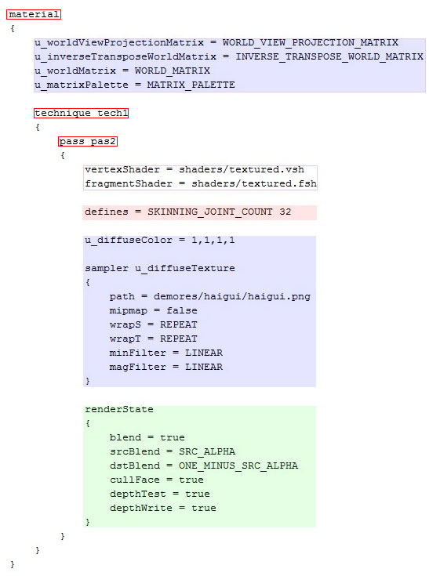

Tips: 1: Above, the basic structure supported by the Cocos3D engine material script, the parameters of the first blue region using the automatic assignment mechanism by the Cocos3D engine, Cocos3D also supports the following common values of automatic assignment:：

// Binds a node's World matrix.

WORLD_MATRIX,

// Binds the View matrix of the active camera for the node's scene.

VIEW_MATRIX,

// Binds the Projection matrix of the active camera for the node's scene.

PROJECTION_MATRIX,

// Binds a node's WorldView matrix.

WORLD_VIEW_MATRIX,

// Binds the ViewProjection matrix of the active camera for the node's scene.

VIEW_PROJECTION_MATRIX,

// Binds a node's WorldViewProjection matrix.

WORLD_VIEW_PROJECTION_MATRIX,

// Binds a node's InverseTransposeWorl matrix.

INVERSE_TRANSPOSE_WORLD_MATRIX,

// Binds a node's InverseTransposeWorldView matrix.

INVERSE_TRANSPOSE_WORLD_VIEW_MATRIX,

// Binds the position (C3DVector3) of the active camera for the node's scene.

CAMERA_WORLD_POSITION,

// Binds the view-space position (C3DVector3) of the active camera for the node's scene.

CAMERA_VIEW_POSITION,

// Binds the matrix palette of C3DMeshSkin attached to a node's model.

MATRIX_PALETTE,

// Binds the total time and delat time.

TIME_PARAM,

2： Valid attributes and macros used by the material script depends on the shader’s impliments.

# Debug

Developers can use the model editor for material script debugging.

